STOCK MANAGEMENT SYSTEM

**PROBLEM STATEMENT**

* The stock maintenance system which take care of sales information of the company and analyze the potential of the trade. It maintains the data in efficient manner. The existing system was recorded manually on pen and paper and time consuming one. To overcome this we are operating it in system and database for delivering accurate and real time information on stocks. This is also helps in calculating the total stocks, pending stocks and updating. It is mainly used in business sector to maintain stock level and profit and unprofitable product. This is mainly used by sales person and customers. This system is used for time and money saving, increases productivity and efficiency and also used for accurate data analysis of stocks. Also used for analysis the data in real-time requirements of the stocks.

**PURPOSE**

* The entire process of stock maintenance is done in a manual manner considering the fact that the number of customer for purchase is increasing every year, a maintenance system is essential to meet the demand. So this system uses several programming and database techniques to elucidate the work involved in this process.

**SCOPE**

* The system provides an interface to the customer where they can fill in orders for the items needed.
* The sales person is concerned with the issues of items and can use this system.
* Provide a communication platform between the customer and the sales person.

**IMPORTANCE**

This helps us to access and manage the information easily. This also helps to verify the stock currently available with them and to update the stock when necessary. This also reduce the time to search the product from the current available stock. The role of an inventory system is to track your products and supplies. Inventory management is the process of controlling of the ordering, storage and use of components that a company uses in the production of the products it sells.

# OVERVIEW AND PLANNING

# SRS includes two sections overall description and specific requirements

# OVERALL DESCRIPTION:

# It will describe major role of the system components and inter connections.

# SPECIFIC REQUIREMENTS:

# It will describe roles and functions of the actors.

**PROPOSED SYSTEM OVERVIEW**

This system has the following modules

# Login:

The seller gives the user name and password and logs into the system.

# Register:

The seller gives the necessary details and register into the system

# View and select product:

The database contains the list of available products and are displayed when selected.

The total amount of the selected produced is displayed.

To maintain the customer and owner relationship discount option is added

* **Billing:**

On selecting the products and quantity the amount is displayed along with the details of selected products

**OVERALL DESCRIPTION**

**PRODUCT PERSPECTIVE:**

The stock maintenance acts as an interface between the ‘customer’ and the ‘sales person’. This system tries to make the interface as simple as possible and at the same time not risking the work of data stored in.

**SYSTEM FUNCTIONS:**

* secure order of information by the customer.
* schedule the customer an appointment for normal delivery of the product.

USER CHARACTERISTICS

**CHALLENGES**

* To explain that this software is better than manual system.
* To explain the detail process involved in the software.
* To develop a software which easy to use and avoid complexity.
* The software should satisfy the user needs.
* To provide accurate database services.
* To make sure that the software works at the user place (user environment).
* Mis-communication between the sales and the supply chain management team.

**ASSUMPTIONS**

* Based on the sales orders given to the supply chain management they check the availability of the raw materials and then they supply and manufacture products.
* The inventory system has the list of the products and quantity of the products. Depending upon the sales of the product the exact details about the product is displayed to the user.
* From this the customers selects the product to sell.

**ARCHITECTURE SPECIFICATIONS**

* The architecture of inventory management system uses client server model
* The design or architectural specification for the inventory management system is Java since the JSP architecture will be used.
* The Java Database Connectivity (JDBC) will use the MySQL Connector for the server to communicate to the inventory database.
* Upon receiving requests from the clients, the server will issue transactions to the MySQL database.

**HARDWARE REQUIREMENTS**

* PROCESSOR : 64-bit
* ROM :2GB
* RAM :4GB

**SOFTWARE REQUIREMENTS**

* OPERATING SYSTEM: windows 8/10
* FRONT END : java netbeans
* BACK END : mysql

# SYSTEM DESIGN

* 1. High-Level Design

# USECASE DIAGRAM

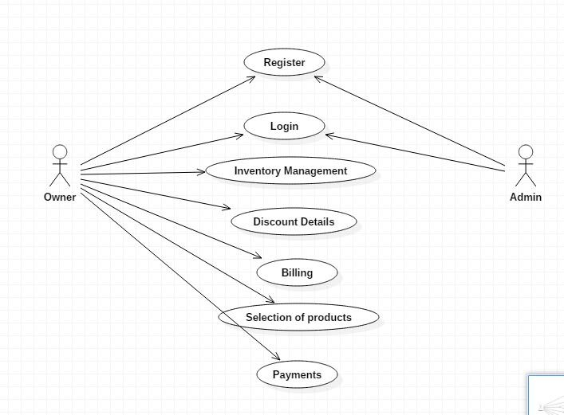

**STATECHART DIAGRAM**

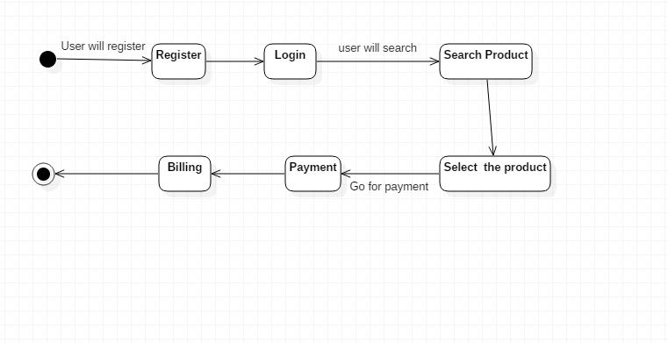

# CLASS DIAGRAM

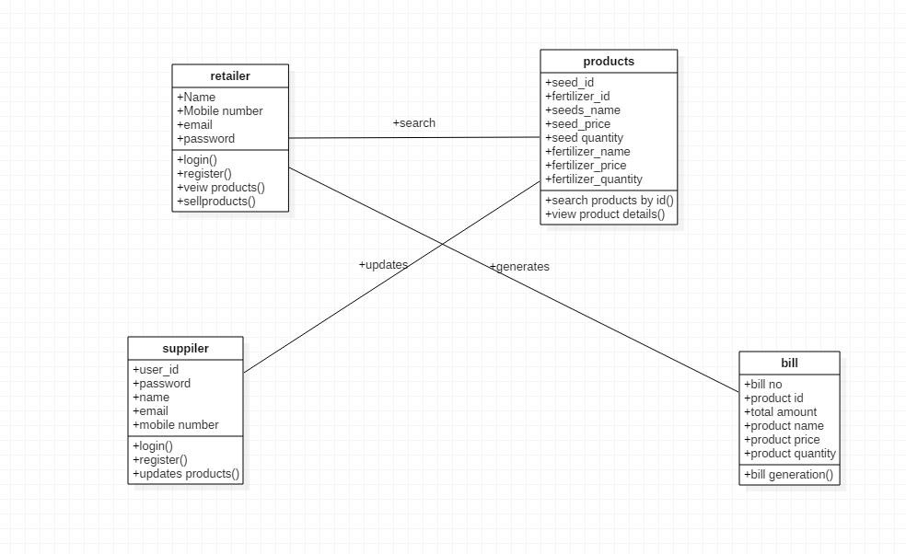

**SEQUENCE DIAGRAM**

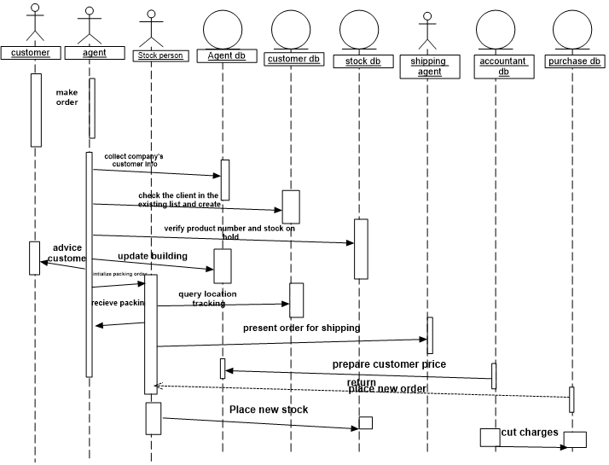

**COLLABORATION DIAGRAM:**

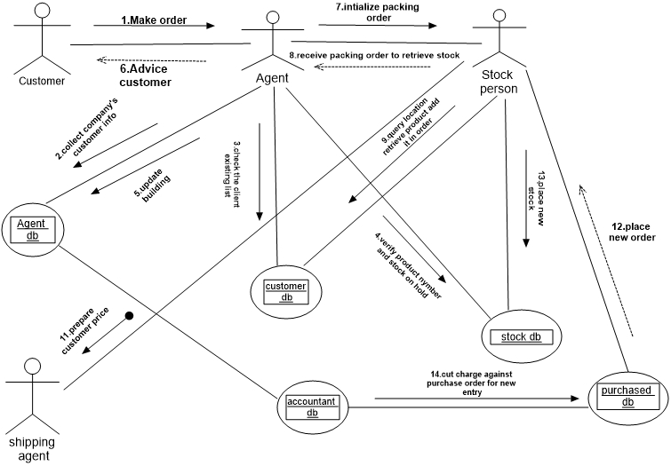

**ACTIVITY DIAGRAM:**

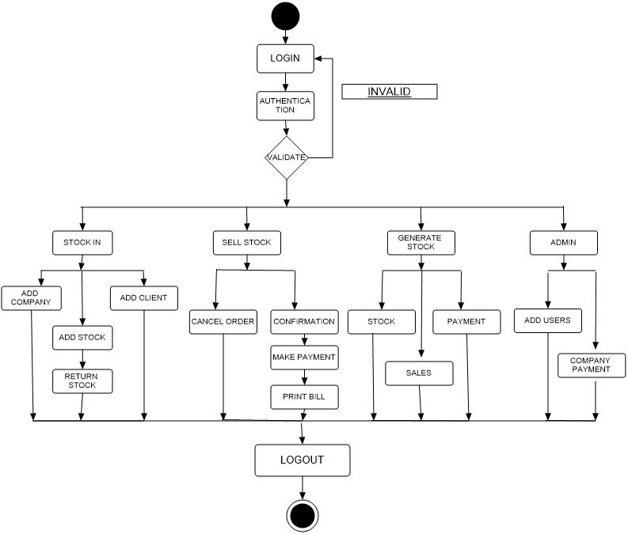

**LOW-LEVEL DESIGN**

# ER DIAGRAM

**ACTIVITY DIAGRAM**



**COLLABARATION DIAGRAM**



**SEQUENCE DIAGRAM**



**SYSTEM IMPLEMENTATION**

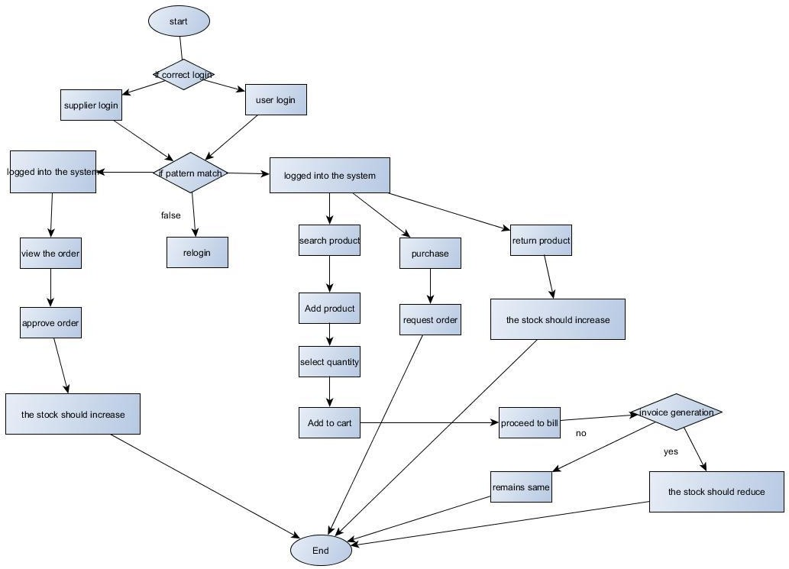

**OUTPUT/RESULTS**

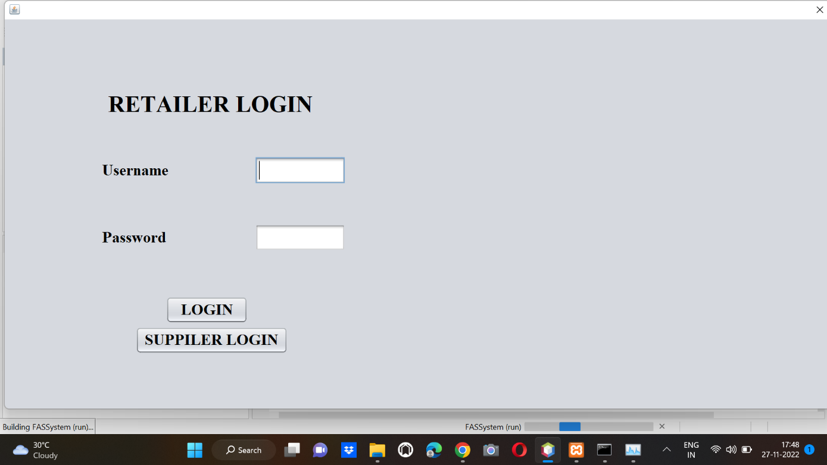

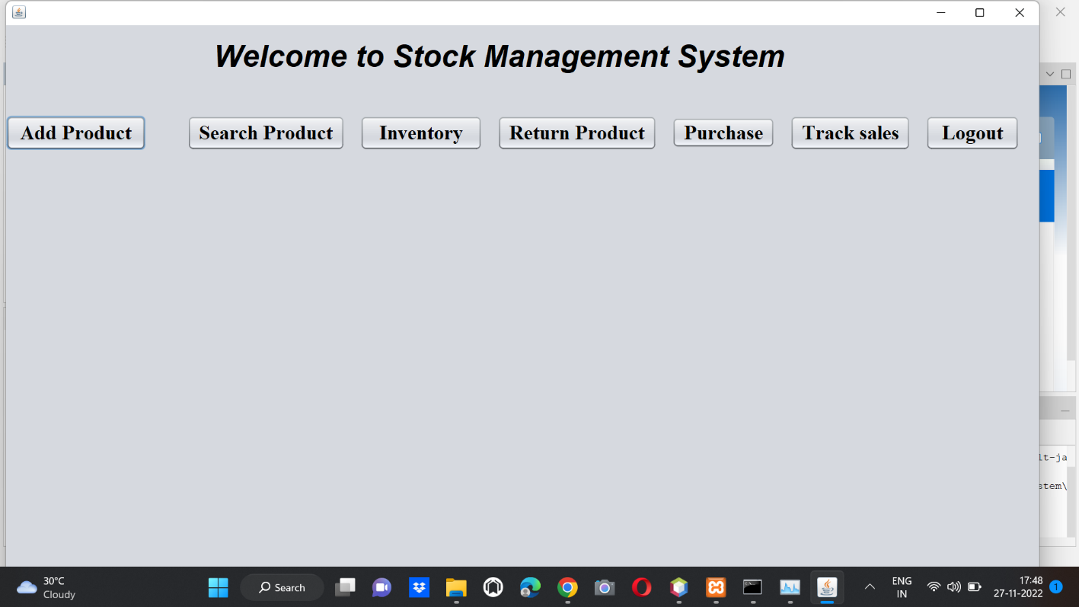

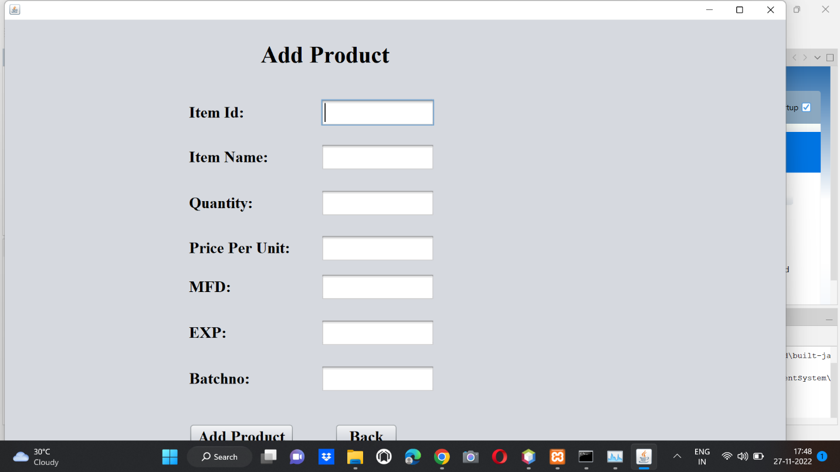

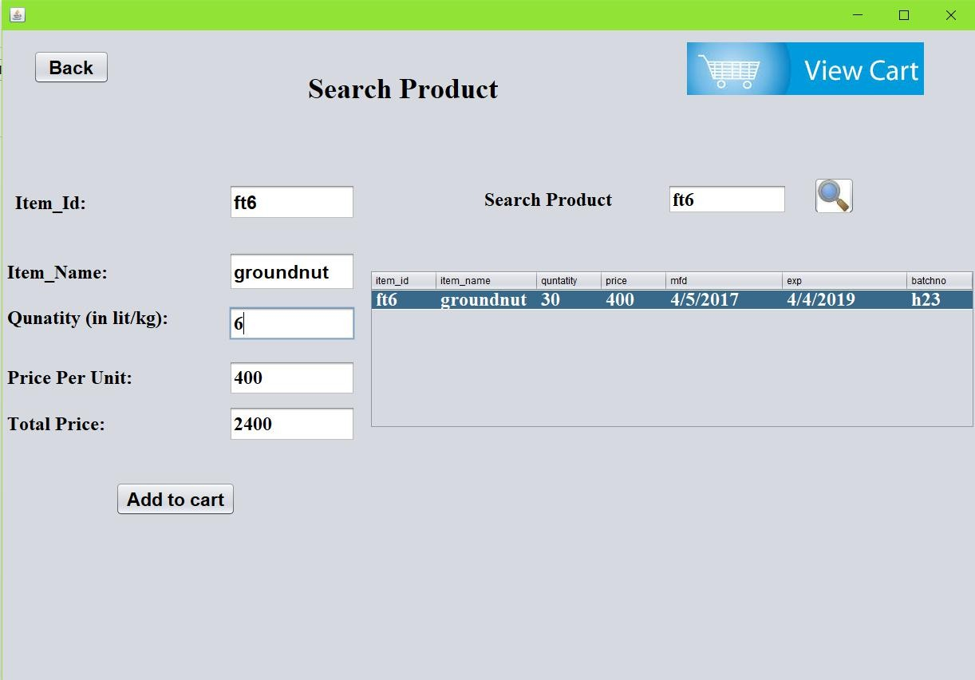

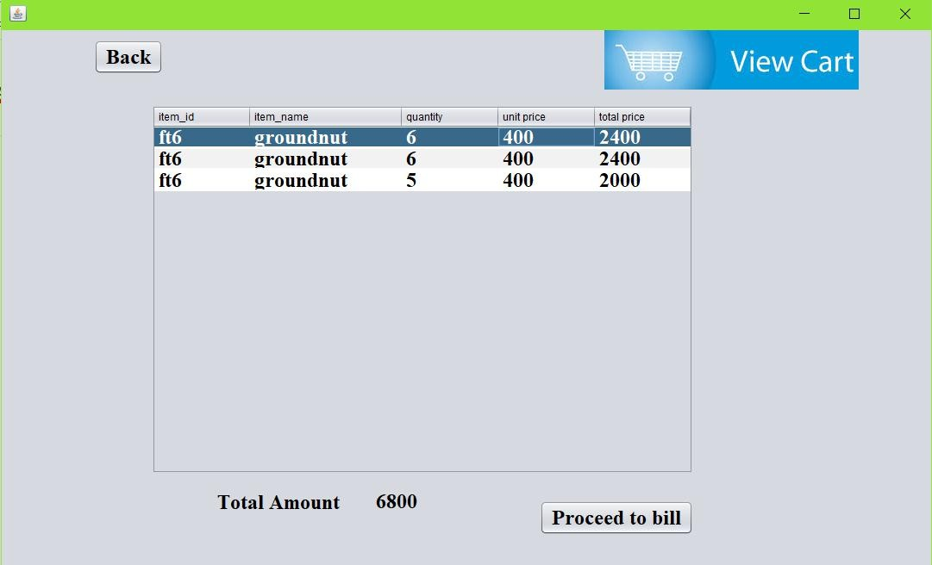

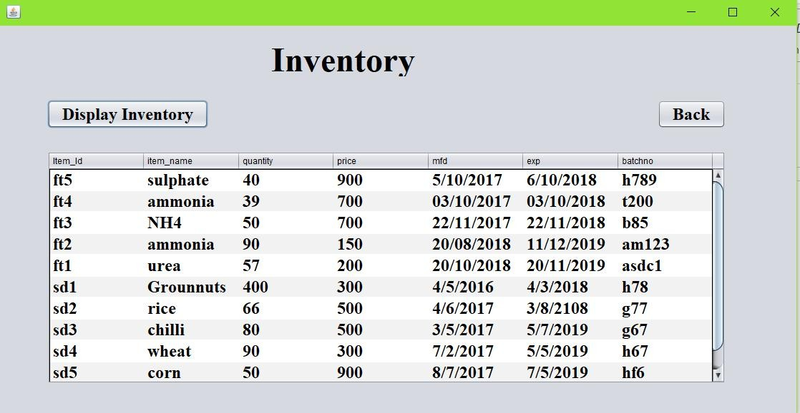

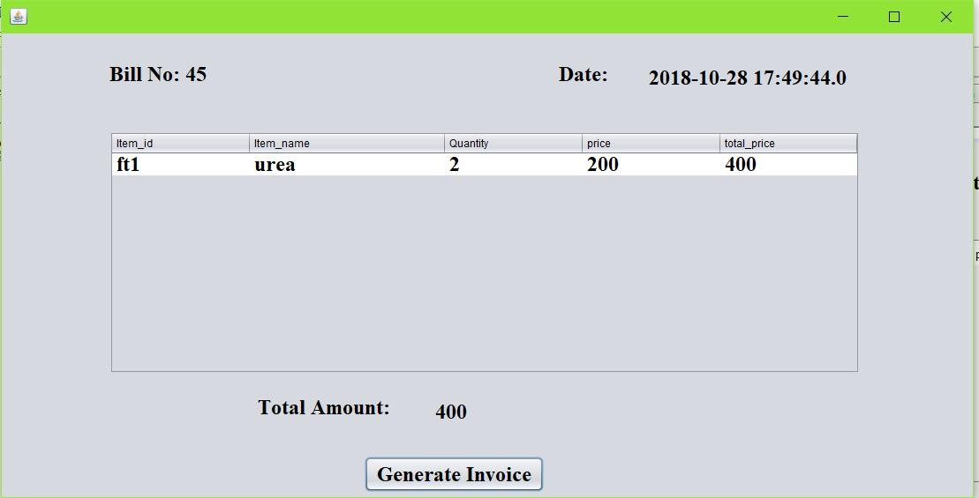

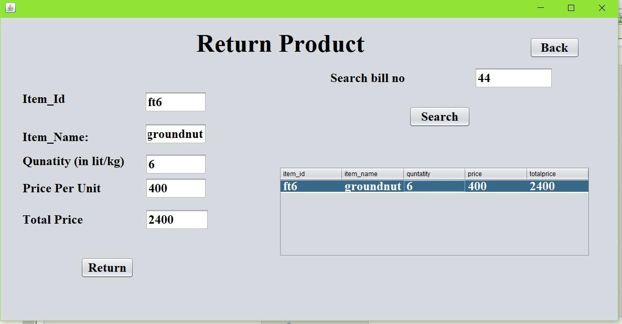

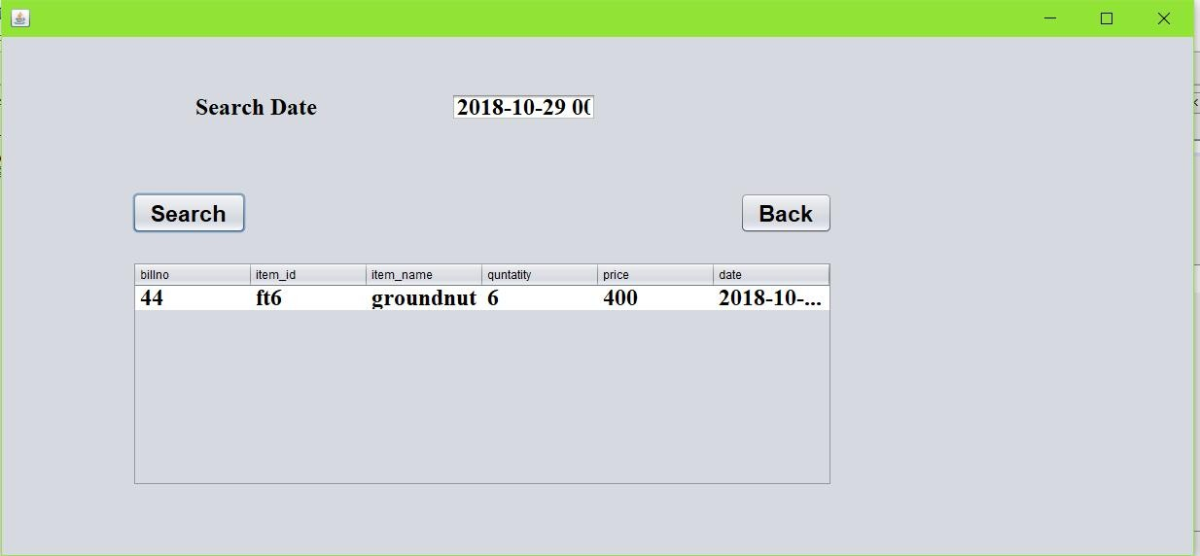

# DISCUSSION

In future the products can be scanned with the help of barcode scanner. A system can be developed to take order from the customers online and deliver them. The customer relationship can be built with the help of feedback.

# CONCLUSION AND FUTURE DEVELOPMENTS

In this project we have developed a system which helps the retailers to sell and manage their products easily. It covers the functional areas of erp such as Marketing and sales, Supply chain management, Accounting and Finance and Human Resources. So this can help in increasing the sales of the retailer through the help of the inventory management. So the required products can be bought based on the demand. In future the products can be scanned with the help of barcode scanner. A system can be developed to take order from the customers online and deliver them. The customer relationship can be built with the help of feedback.